Researching Methods to Improve Cell Detection

Most Promising Methods are at the Top

# Adaptive Thresholding (Proven Successful!!)

Adaptive thresholding is an image processing technique used to convert a grayscale image into a binary image. Unlike global thresholding, which applies a single threshold value to the entire image, adaptive thresholding calculates a threshold for smaller regions of the image. This approach is particularly effective in scenarios where lighting conditions or color variations vary across the image.

**Process:** Local Region Analysis (The image is divided into smaller, overlapping regions or blocks), Threshold Calculation, Binarization (Pixels in each block are converted to either 0 (black) or 255 (white) based on whether they are above or below the calculated threshold for that block)

**Benefits for Stained Cell Detection** Stained cell images often suffer from uneven lighting, making it difficult to apply a single global threshold. Adaptive thresholding mitigates this issue by adjusting the threshold based on local image content. Adaptive thresholding also helps in highlighting features (like stained cells) that might be obscured by variations in background or staining intensity. By adapting to local conditions, it can better separate the cells from the background.Cells often have irregular shapes and edges that can be lost with global thresholding. Adaptive thresholding preserves these features, making it easier to detect and outline individual cells.It can also be more robust in the presence of noise since it focuses on local characteristics, reducing the influence of noise across the entire image. Since stained cells are typically defined by their contours, adaptive thresholding enhances the detection of these boundaries, facilitating more accurate contour extraction for further analysis.

# Watershed Algorithm

<https://www.geeksforgeeks.org/image-segmentation-with-watershed-algorithm-opencv-python/>

<https://docs.opencv.org/4.x/d3/db4/tutorial_py_watershed.html>

**The Watershed algorithm** is a powerful technique used in image processing for contour detection, particularly in segmenting objects from the background.

* It treats the image as a topographic surface and finds the lines that separate different regions.
* “The segmentation process will take the similarity with adjacent pixels of the image as an important reference to connect pixels with similar spatial positions and gray values”
* It excels with irregular object shapes, with images that have a lot of noise, and touching/overlapping objects, which can be useful with the irregular shapes of some of the cells.

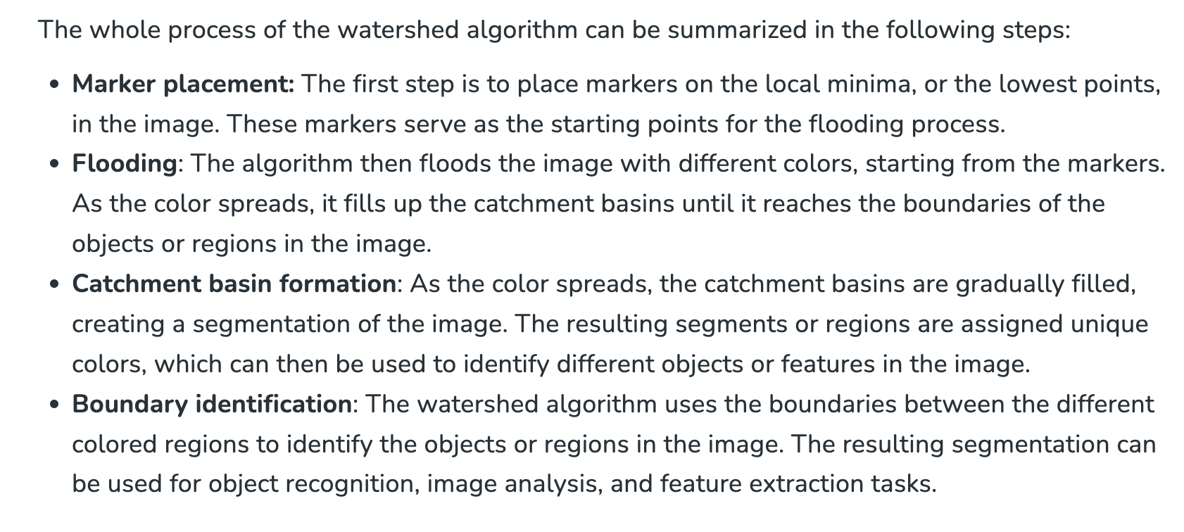

* This might make slice identifying more accurate, which can filter out some of the errors we have been encountering

# Erosion

* Erosion shrinks the boundaries of foreground objects (usually represented by white pixels in a binary image) by removing pixels on their edges.
* Erosion effectively removes small noise points or isolated pixels (often called "salt" noise)
* Erosion removes small noise points (e.g., tiny artifacts) that do not represent actual cells. This is particularly useful when images contain stray pixels or small debris that could lead to false detections.
* **Shape Simplification**: Erosion simplifies the shape of cells by shrinking their boundaries

# Dilation

* Dilation expands the boundaries of foreground objects by adding pixels to their edges.
* Dilation can fill small holes and gaps in objects, making them more complete and connected, which can help with the continuity of features in an image.
* Dilation expands the boundaries of cells, helping to connect nearby or touching cells. This is important in cases where cells may be slightly overlapping or have gaps between them.
* *Dilation: In cases like noise removal, erosion is followed by dilation. Because erosion removes white noises, it also shrinks our object. So we dilate it. Since noise is gone, they won’t come back, but our object area increases. It is also useful in joining broken parts of an object.*

# Color Deconvolution

* Color Deconvolution and separating by stain
* QuPath might need to be reintroduced here
* This method is particularly important for cell detection, as it allows for the quantification of different stains used to highlight specific cellular structures
* Stain Matrix: Create a stain matrix that represents the absorption characteristics of each stain. For example, a matrix might contain the color information for Hematoxylin and Eosin.

# Hungarian Algorithm

* Hungarian algorithm, allows you to accurately match stained cell shapes in histological images while ensuring that each cell is uniquely paired
* Each cell shape is represented in a cost matrix, where the element at position (𝑖,𝑗) (i,j) indicates the similarity (or distance) between the stained cell shape 𝑖
* i and the reference shape j. A lower cost indicates a better match.Assignment: The algorithm finds the optimal one-to-one assignment of shapes such that the overall cost is minimized, ensuring that each stained cell shape is matched to only one reference shape.
* Avoiding Double Matching: The algorithm inherently prevents double matching by using a bipartite graph approach, where each agent can be assigned to only one task.

# Greedy Algorithm

* While not guaranteed to find the global optimum like the Hungarian algorithm, the greedy algorithm is computationally efficient and works well for smaller datasets or when a quick solution is needed. The greedy nature of the algorithm ensures that once a cell shape is matched, it is excluded from consideration for future matches, preventing double matching.

# Integer Linear Programming

* The matching problem is formulated as an ILP model, where variables represent potential matches between stained cell shapes. Each variable is binary, indicating whether a specific match is selected (1) or not (0).
* Objective Function: The goal is to minimize (or maximize) a cost function that quantifies the dissimilarity between matched shapes, often derived from similarity scores or distance metrics.
* Define a constraint so that each cell shape can be matched to at most one other shape, ensuring unique assignments

# Gaussian Smoothing

* Gaussian smoothing, also known as Gaussian blur, is an image processing technique used to reduce noise and detail in an image. It works by applying a Gaussian function, which creates a bell-shaped curve, to assign weights to neighboring pixels based on their distance from a central pixel. This results in a weighted average that emphasizes closer pixels while diminishing the influence of father ones.
* Kernel: A Gaussian kernel (matrix) is applied over the image. The size and standard deviation of the kernel determine the extent of smoothing.
* Blurring: The process blurs the image, which can help in reducing high-frequency noise that can interfere with image analysis.
* Preservation of Edges: Although Gaussian smoothing blurs the image, it tends to preserve edges better than uniform smoothing techniques, which can be advantageous in certain applications.

# Morphological Operations

* Morphological operations are a set of image processing techniques that process images based on their shapes or structures. They are particularly useful for binary images, where the primary goal is to manipulate the structure of foreground objects while ignoring the background. The operations rely on a structuring element, a predefined shape that determines how the operation is applied to the image.
* Erosion: Removes pixels from the boundaries of foreground objects, effectively shrinking them. It can eliminate small noise points.
* Dilation: Adds pixels to the boundaries of foreground objects, expanding them. It can fill small holes and connect nearby objects.
* Opening: Erosion followed by dilation. This operation helps remove small objects (noise) while preserving the shape of larger objects.
* Closing: Dilation followed by erosion. This operation fills small holes and gaps within the foreground objects, making them more complete.
* Benefits for Stained Cell Detection and Slicing
* Noise Reduction: Morphological operations, especially opening, are effective in removing small noise elements that could interfere with the detection of stained cells. By cleaning up the image, these operations ensure that only relevant structures are analyzed.
* These operations maintain the general shapes of stained cells, which is crucial for accurate identification and measurement. For example, closing can help fill in gaps in the cell outlines, leading to more accurate contour representation. Dilation can help connect nearby stained cells or fill small gaps between cells, making it easier to detect clusters or aggregates of cells. This is particularly useful in tissues where cells may be closely packed. Removing Artifacts: Erosion and opening can effectively remove small artifacts that may appear in stained images, ensuring that only relevant biological structures are considered during analysis.

# Merging Close Contours

* Merging close contours is an image processing technique that addresses the challenge of separating or combining contours in binary images. Contours represent the boundaries of shapes, and in cases where objects (such as stained cells) are closely packed together, these contours may overlap or be too close to be distinguished effectively. Merging close contours involves analyzing the distances between contours and combining them when they fall within a specified threshold.
* When stained cells are densely packed, their contours may overlap, making it difficult to segment them accurately. Merging close contours can help create a clearer representation of individual cells, leading to more effective segmentation. By merging contours that represent close or adjacent cells, this technique can reduce the likelihood of detecting false positives or erroneously separating parts of the same cell. This results in more accurate cell counts and measurements. When contours are merged, it can simplify the analysis of individual cells by providing a unified shape. This is particularly useful for calculating properties like area, perimeter, and shape descriptors. Merging criteria can be adjusted based on specific needs, allowing for flexibility in handling different staining patterns, cell types, and densities.